**TUTORIAL 3**

3.Prepare a detailed test report with test cases, results, and bug report for a tested module.

Test Report – LAKME Application (Product Search & Filter Module)

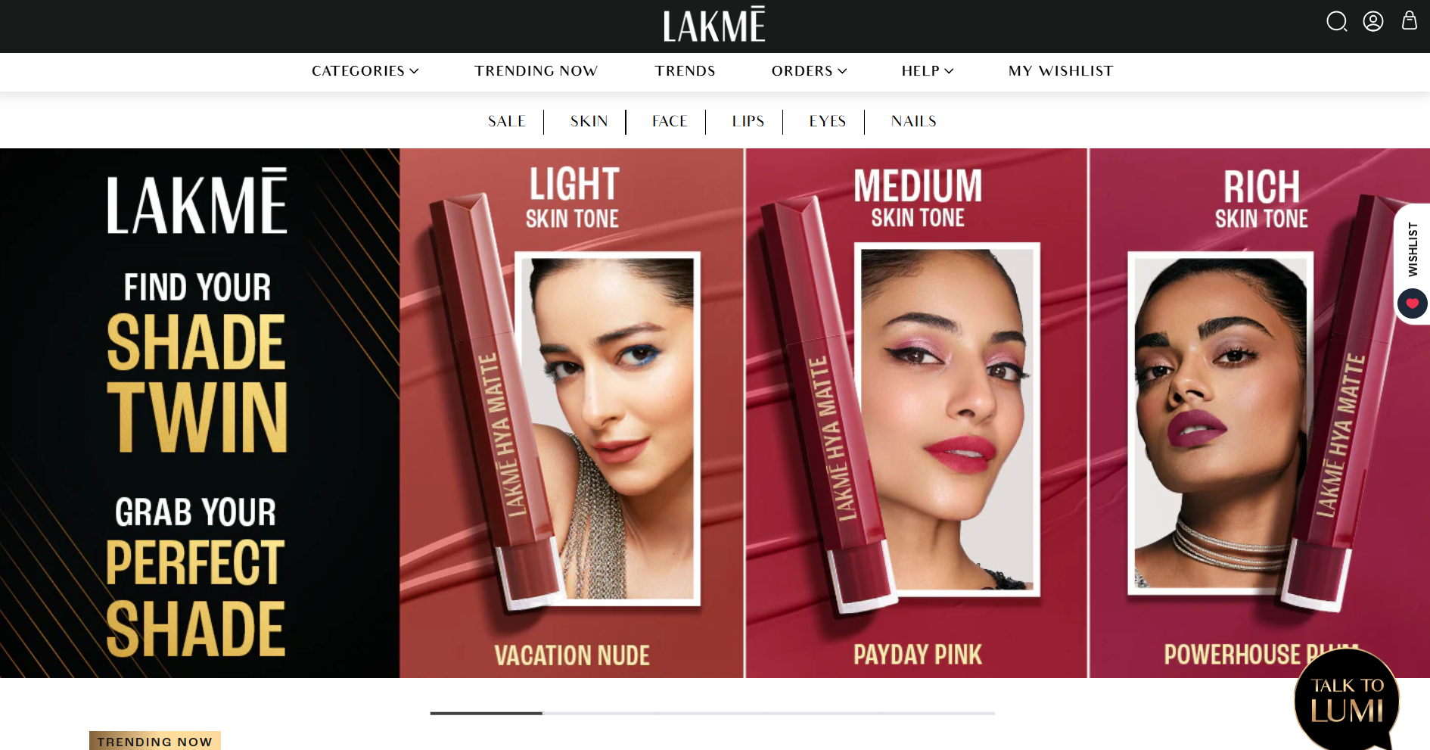

**1.Module Tested**

Product Search & Filter – ensures users can search for beauty products and apply filters (brand, price, category)

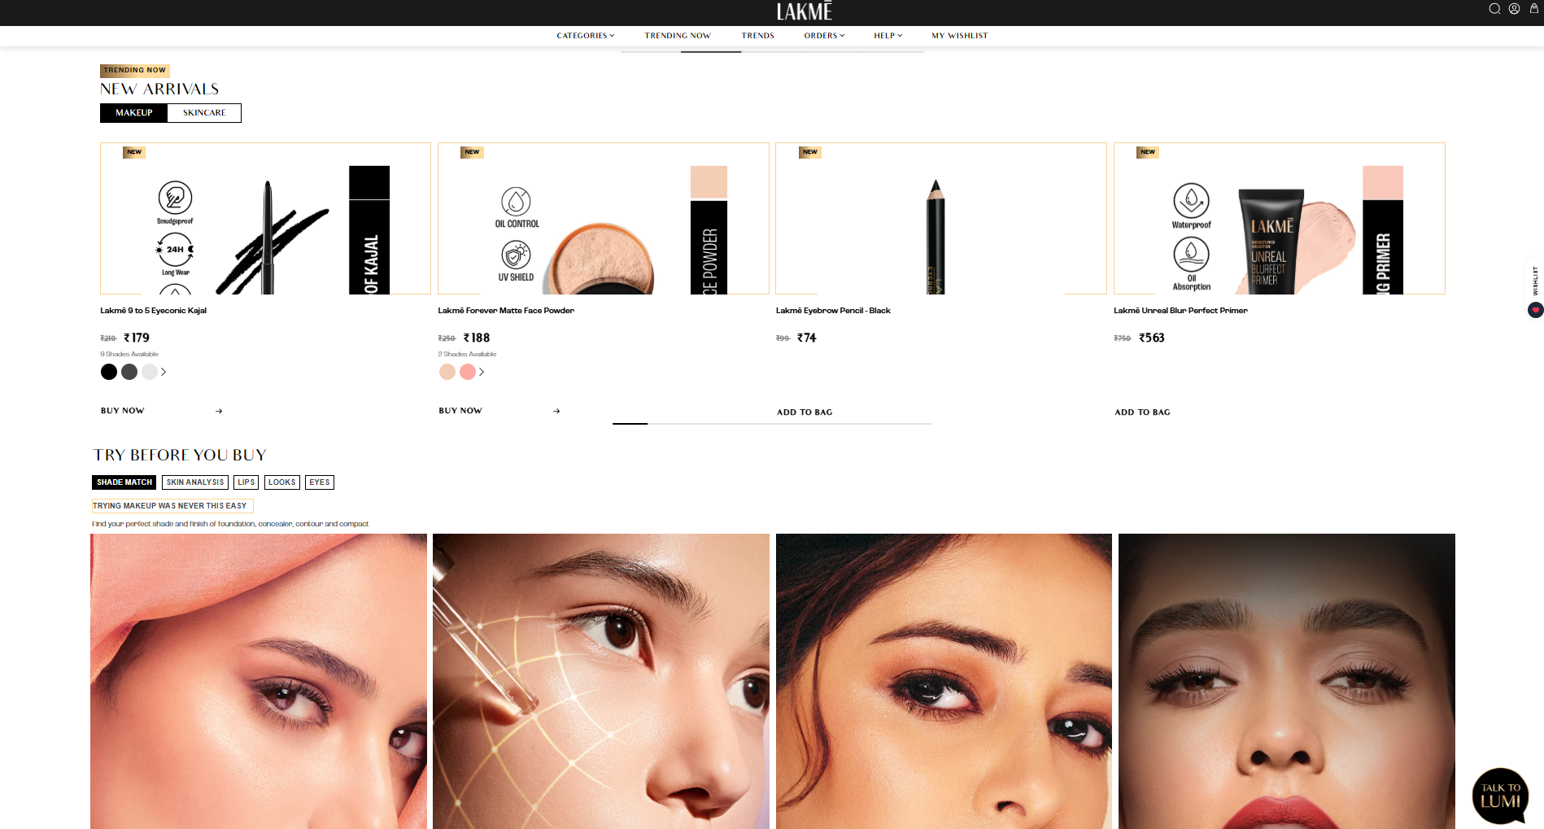

**2. Testing Details**

Field Info

Tester Name QA Team – LAKME Project

Test Cycle Sprint 12 (Regression + Functional)

Environment Android v14, iOS 17, Chrome v118

Database MongoDB 5.0 3)

**3.Environment Details**

Application: LAKME App (Android 13, iOS 16) & Web

Test Environment: QA/Staging

Browsers: Chrome v116, Safari v15

Devices: Pixel 6 (Android 13), iPhone 13 (iOS 16)

Database: PostgreSQL 12 (staging)

Builds: Android vX.Y.Z-qa, iOS vX.Y.Z-qa, Web commit

Test Data: 3 user accounts (fresh, returning, loyalty-enabled), sample addresses (PINs: 400001, 560001), test payment tokens (UPI, Card, COD)

**4) Test Scenarios Covered**

1. Add product to cart

2. Remove product from cart

3. Update quantity & recalculate totals

4. Apply valid/invalid coupons; stacking rules

5. Tax (GST) calculation by line item

6. Shipping fee & free-shipping threshold logic

7. Address selection & PINCODE serviceability

8. Proceed to payment & gateway redirection (UPI/Card/COD)

9. Payment success/failure handling & recovery

10. Order confirmation (UI + Email/SMS)

11. Cart persistence across sessions/devices

12. Price change/stock change during checkout

**5) Test Cases & Results**

**TC-01 — Add product to cart**

Steps: PDP → “Add to Cart” (₹599 item, in stock)

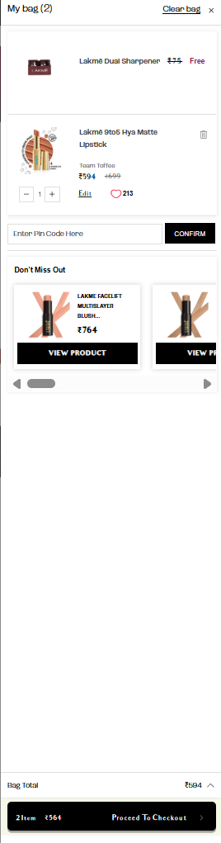

Expected: Item added; mini-cart shows qty=1, subtotal=₹564

Actual: As expected

Status: ✔ Pass

**TC-02 — Remove product from cart**

Steps: Cart with 1 item → “Remove”

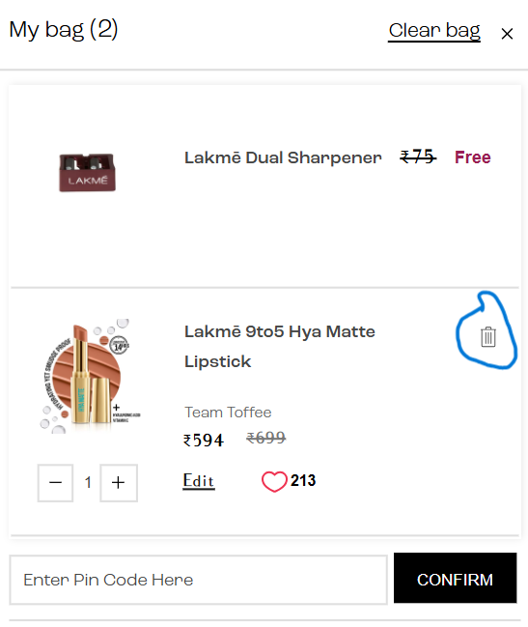 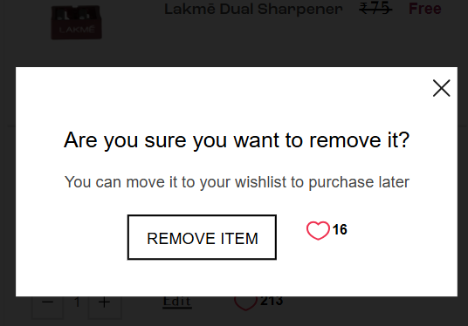

Expected: Item removed; cart empty state shown

Actual: As expected

Status: ✔ Pass

**TC-03 — Update quantity and recalculate:**

Steps: Qty 1→3 on ₹1000 item

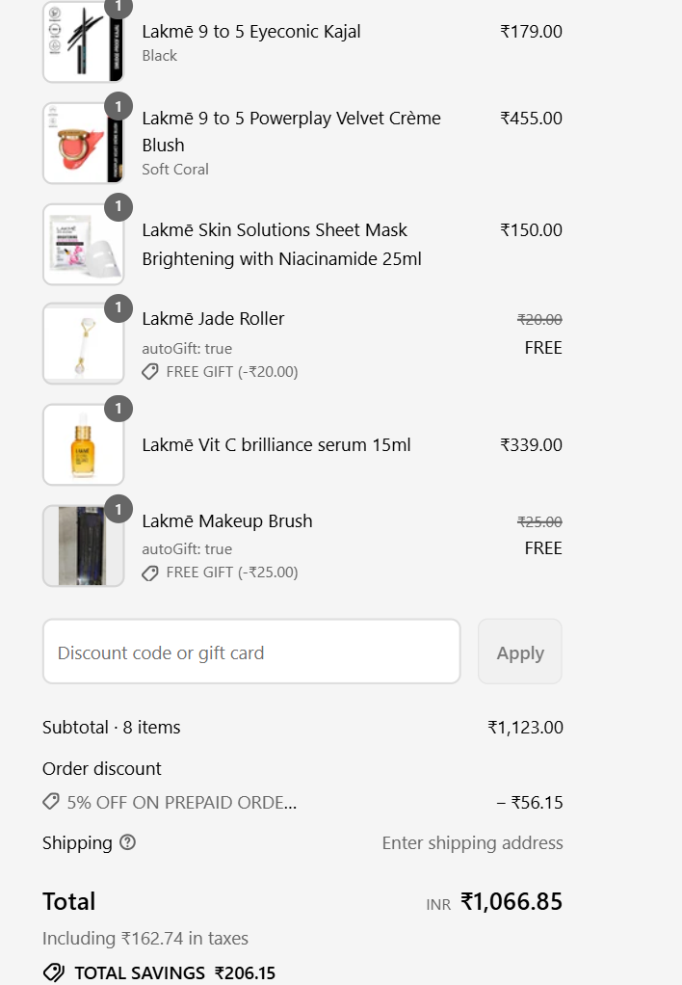

Expected: Subtotal ₹1100; GST & total updated correctly Actual: Total = ₹1066.85; taxes correct.

Status: ✔ Pass

**TC-04— Discount :**

Steps: Cart ₹563 → Discount ₹5% → decrease cart to ₹534.85

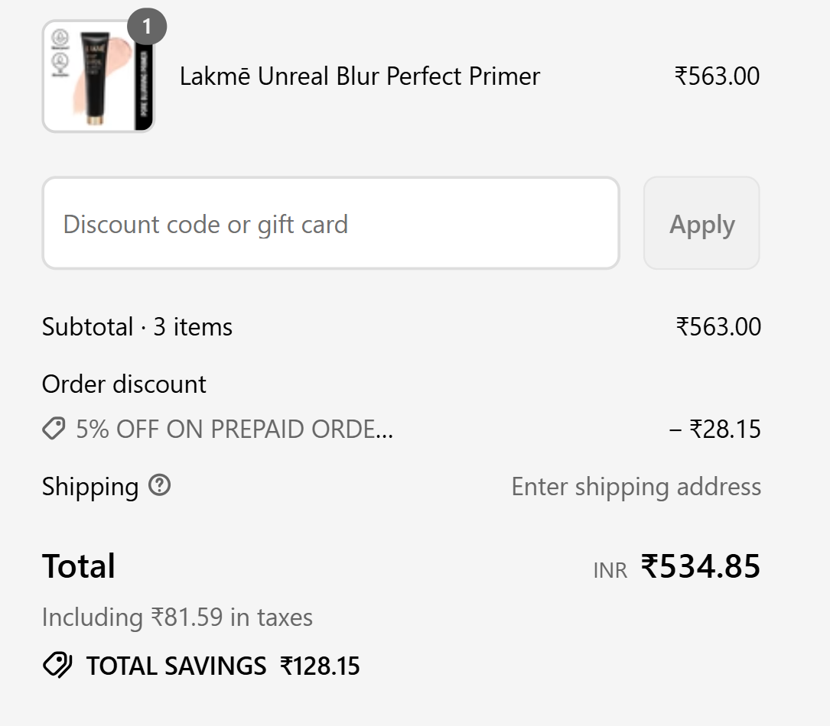

**TC-05 — Apply valid coupon.**

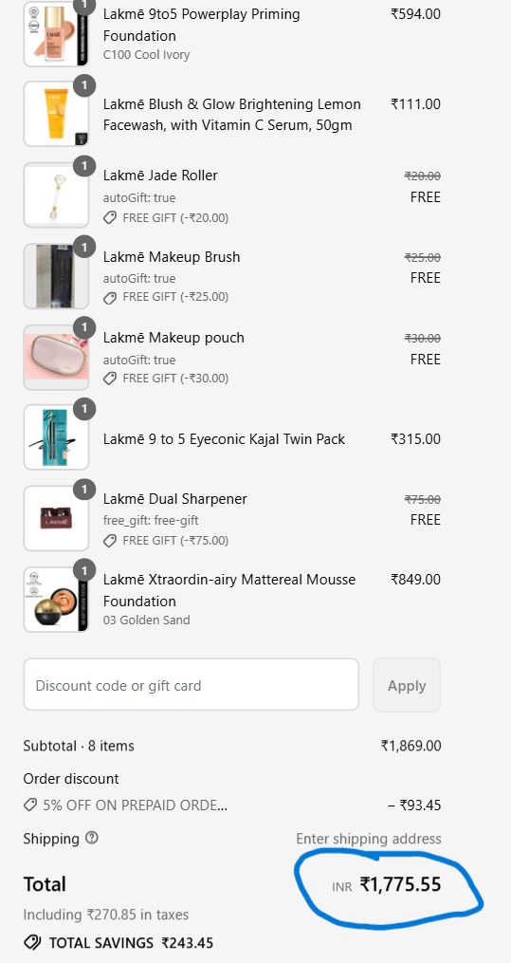 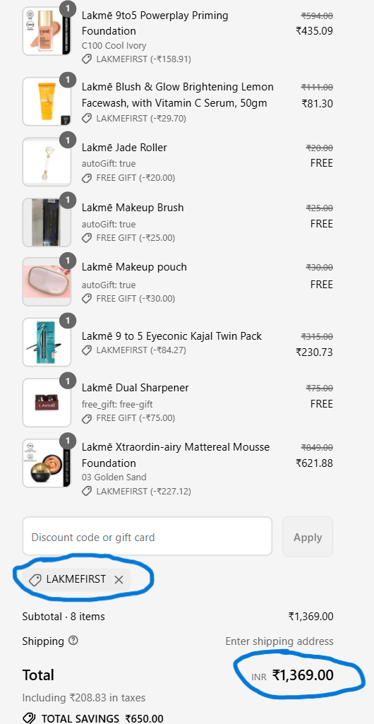

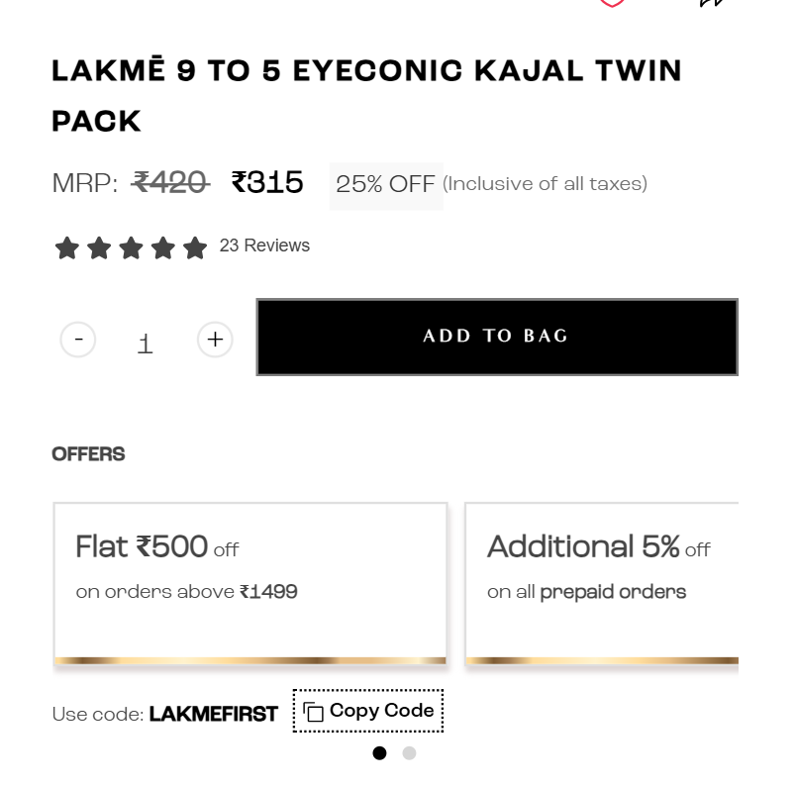

Input: LAKMEFIRST on cart ₹1,499 (eligible first-order user)

Expected: ₹500 flat discount applied; total adjusts; success toast

Actual: As expected

Status: ✔ Pass

**TC-06 — Invalid coupon**

Input: LAKME456 (non-existent)

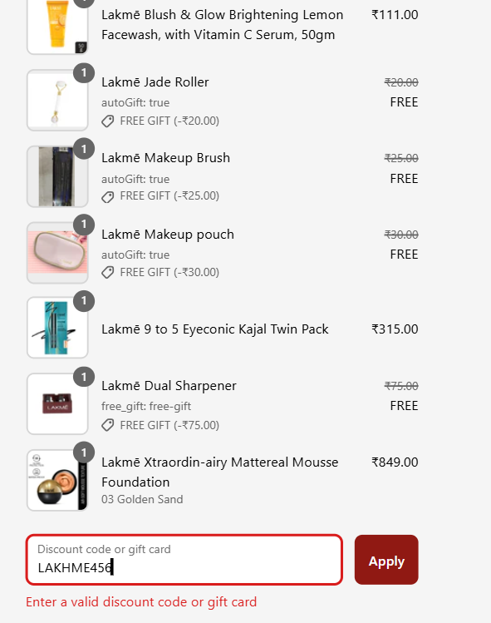

Expected: Validation error “Invalid coupon” Actual: As expected

Status: ✔ Pass

**TC-07 Payment: Redirection**

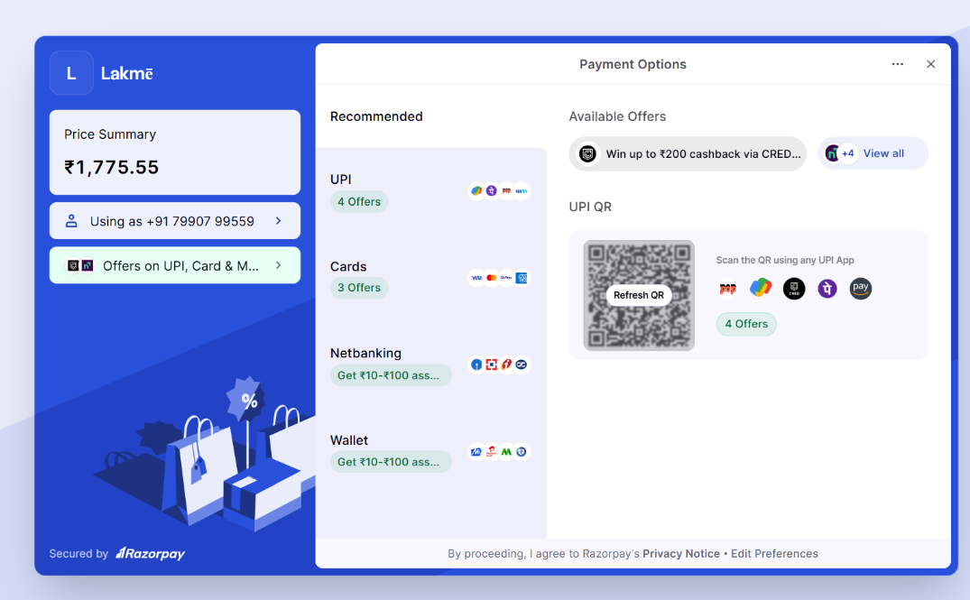

Steps: Choose UPI → Pay

Expected: Redirect to UPI intent; return success Actual: As expected (flow stable)

Status: ✔ Pass

**TC:08 Invalid UPI: VPA.**

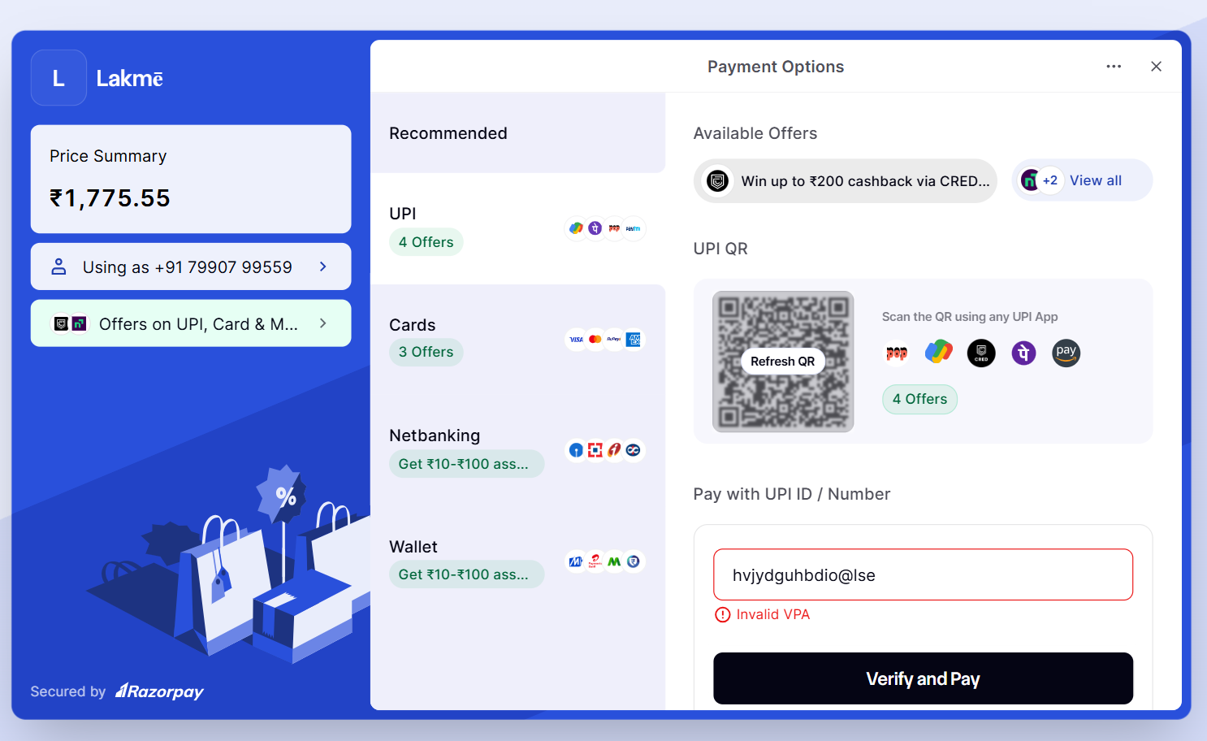

Expected: Error In VPA

Actual: As expected

Status: ✔ Pass

**TC-09 — Order confirmation.**

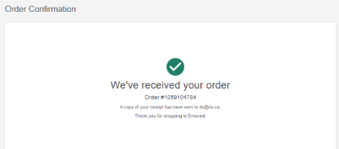

Steps: Successful order

Expected: Confirmation Tick, with Email.

Actual: Email received.

Status: Pass

**Bug Report 1**

Field Description

Bug 1 – Brand filter not working properly

ID: PUR-SEARCH-001

Security: High

Steps: Search → Apply Brand “LAKME”

Expected: Only LAKME products

Actual: Other brands also listed

**Bug Report 2**

Field Description

Bug 2 Combined filters return wrong results

ID: LAK-SEARCH-003

Security: High

Steps: Apply Brand + Price filter together

Expected: Filtered accurate results

Actual: Extra irrelevant products appear

**Bug Report 3**

Field Description

Bug 3 Clear Filters button not functional

ID: LAK-SEARCH-004

Security: Medium

Steps: Apply filters → Click “Clear All”

Expected: All filters reset → All products shown

Actual: Filters remain active

**6. Conclusion**

Current pass rate = 60%, which is not acceptable for release.

Critical issues with brand filtering, combined filters, and reset functionality must be resolved.

**Recommended:** Run re-testing + regression after bug fixes.